Phase 2: Design

Educator: Dl

Name: Steven Groenewald

12 We

Contents

Introduction 2

Program Specifications 3

Users 3

Login Screen 4

Sign Up Screen 6

Main Screen 8

Upgrade Screen 9

Rate App Pane 10

Find a new App 10

Upgrade 10

Admin 11

Admin Verification 11

Add App 11

Edit App 11

Commend User 12

Ban User 12

Operators 12

Top 10 Apps 12

Database Specifications 14

Table Relations 14

AppTbl 14

GenreTbl 14

AdminVoteTbl 14

CompatabilityTbl 14

UserTbl 14

ReviewTbl 14

Table Specifications 15

CompatabilityTbl 15

GenreTbl 15

AdminVoteTbl 15

AppTbl 15

Users 15

ReviewTbl 16

Data Structures 18

Classes 18

Review Management 19

# Introduction

My programme will allow users to review and rate apps across different OS and genres to allow then the best selection while giving them a completely unbiased and honest review system. Administrators will be allowed to remove troublesome/fake users. It will be in English as the Lingua Franca for now.

In the future, I would like to run it through a web page as well as an app release on all OSs and sync it to a server. This improves the integrity and importance of the information that is generated, while allowing us to directly reach the target market on their devices.

# Program Specifications

These IPO tables are grouped into 3 divisions, User and Admin – which are available to clients who use the software as well as Operator – which refers to the programmers and business people who use the programme to make basic reports on app use and popularity over a variety of metrics.

## Users

It is worth noting that anything a user can do an admin can do as well.

### Login Screen

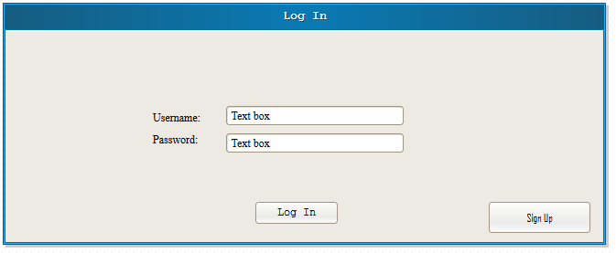

This is the first screen that is displayed when the program is launched.

|  |  |  |  |  |
| --- | --- | --- | --- | --- |
| Input | Data Validation | Processing | Error Message | Output |
| Username typed into a text field. | The username is checked to be the right length (12 characters), with the first four being letters, the next four being numbers and the last four are capital letters. |  | The user name doesn’t exist on our database; please check the email we sent you when you created your account. |  |
| Password typed into a text field. | The password is also checked to be the right length (10) with the first 3 being the first 3 letters being the first 3 letters of one of 6 colours. Depending on the colour, a different Caesar shift is run, on the original three of the colour, to create the next three characters of the password. The last 3 characters are randomly created and assigned numbers. The last character of the password is a 0 as long as the password has not occurred before – if it has occurred before, it is a 1. Thus it increases by one every time the password has already occurred, this prevents duplicates. |  | Password is not correct; check your inbox for our email containing the correct password. |  |
| The user clicks on the “Log In” button |  | The password is checked to match the password of the specified user. | The user is told that the password is incorrect. | The login screen closes. They are shown a welcome message and the main screen opens. |
| Click on the sign up button |  |  |  | The login screen closes and the signup screen opens. |

### Sign Up Screen

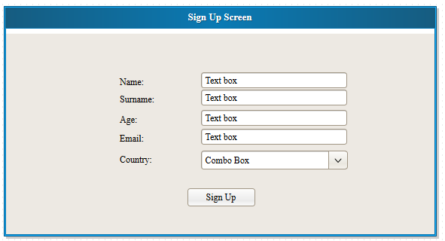

|  |  |  |  |  |
| --- | --- | --- | --- | --- |
| Input | Data Validation | Processing | Error Message | Output |
| Name is entered into a text field. | The name is checked for numbers and symbols |  | “The name you entered is not valid – please remove any numbers or symbols” Is shown in a pane. |  |
| Surname is typed into a text field. | The surname is checked for numbers and symbols |  | “The surname you entered is not valid – please remove any numbers or symbols.” Is shown in a pane. |  |
| Age (in years) is typed into a text field. | The age is checked to only contain numbers and not letters. |  | They are informed that the age should only be in numbers via a pane. |  |
| Email address is entered into a text field. | Email is checked to only contain one @ symbol, it is also checked to see whether another account is using the same email address – this is not allowed. |  | They are informed that the email entered was not a valid address.  OR  They are informed that the email address is already in use. |  |
| Country is chosen from a drop down list – at time of launch there is only South Africa, United States of America and United Kingdom as options. A combo box is used as there are only a few options. |  |  |  |  |
| Click on Sign Up button | All above checks are run. | The new user is created and is inserted into the database. |  | The user gets a message that they have been registered and to check their email. A generated* password and username is sent to the user’s email address, which is used for future emails of importance. They use these details to login. The sign up screen closes and the login screen opens. |

*The username and password are generated as follows:

Username: 1234 5678 9101112

The first four characters are letters, the second group of four characters are comprised of digits and the last four characters are letters in capitals.

Password: 123 456 789 10

The first 3 characters are the first 3 letters of one of 8 colours (red, green, blue, yellow, maroon, brown, purple, black). The next 3 characters are the first 3 letters of the previous colour, shifted using a Caesar shift of 1 through to 8 for the colours as ordered above.

The last 3 characters are randomised a numbers that are assigned to the password.

The 10th character is usually a 0. If however, a database check reveals that the first 9 characters of the password already exist in another password, the program will add one, making the last character 1. If this exists, it will continue up to 9. This avoids any likelihood of duplication of passwords, or at least, makes it highly unlikely.

### Main Screen

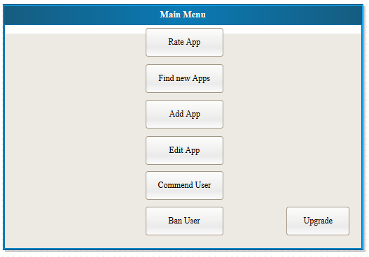

|  |  |  |  |  |
| --- | --- | --- | --- | --- |
| Input | Data Validation | Processing | Error Message | Output |
| Click on the “Rate Apps” button |  |  |  | The Vote pane opens and the main screen closes. |
| Click on the “Find a new App” button |  |  |  | The “Find a new App” pane is displayed and the main screen closes. |
| Click on the “Add App” button |  |  |  | The “Add App” pane is displayed and the main screen closes. |
| Click on the “Edit App” button |  |  |  | The “Edit App” pane is displayed and the main screen closes. |
| Click on the “Commend User” tab |  |  |  | The “Commend User” pane is displayed and the main screen closes. |
| Click on the “Ban User” tab |  |  |  | The “Ban User” pane is displayed and the main screen closes. |
| Click on “Upgrade” button. |  | A request is sent to the server to determine whether the user has more than five administrators who have voted them. If the numbers is 5 or more then the user is made an administrator through a table update. The update changes the isAdmin field of the user who enter t |  | The “Upgrade User” pane is opened and the main screen closes.  “Unfortunately, you have not met the requirements to be an administrator yet. Keep trying!”  Or  “Congratulations! You have been made an administrator. We hope you continue to support the ideals of this project.” |

### Upgrade Screen

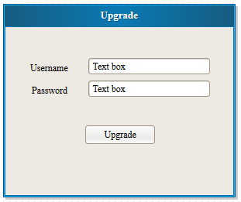

|  |  |  |  |  |
| --- | --- | --- | --- | --- |
| Input | Data Validation | Processing | Error Message | Output |
| Username typed into a text box | Is checked to be a valid username |  | Username does not exist. |  |
| Password typed into a text box | Is checked to be a valid password |  | Password not valid. |  |
| Upgrade Button | Above checks are run. | The password and username are checked to be valid. The user is checked to see if they are eligible. |  | A message tells them they have admin abilities.  OR  A message tells them they are not eligible. |

### Rate App Pane

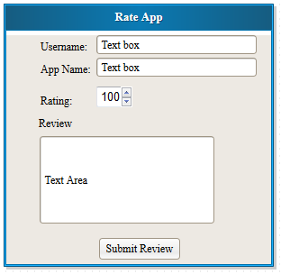

|  |  |  |  |  |
| --- | --- | --- | --- | --- |
| Input | Data Validation | Processing | Error Message | Output |
| Username into a text box. | The username is checked to be valid. | The username is checked to be a existing username. |  |  |
| Rating out of 100 on a spinner as this eliminates the need for data validation. It also suits the rating system. |  |  |  |  |
| A review is typed into a text area. |  | The review field is checked to not be empty. |  |  |
| The name of the App is typed into a text box. |  | The app is checked to exist. |  |  |
| Submit button is clicked. | All above checks are run. | All above processing is run. |  | A message thanks them for rating the App and they are returned to the main menu. |

### Find a new App

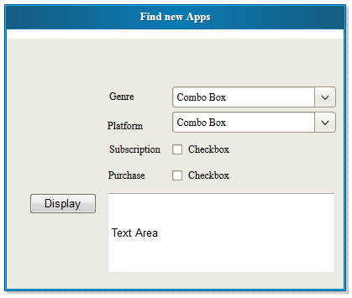

|  |  |  |  |  |
| --- | --- | --- | --- | --- |
| Input | Data Validation | Processing | Error Message | Output |
| A genre is chosen from a list of all genres. This is done as the genre is not something we assume users will know. |  |  |  |  |
| The platform is chosen from a dropdown list. This is done to ensure that the correct platform is selected. |  |  |  |  |
| Subscription is checked if someone wants an app with a subscription pay model. This is a yes/no response that is a deal breaker for most customers. |  |  |  |  |
| Cost is checked if someone wants an app with once off pay model. This is Boolean option with nothing in between so a check box is used. |  |  |  |  |
| The Display Button is clicked. |  | A query is run to only select apps that meet the criteria selected. |  | The result set from the query is displayed in the text area. They are ordered by their rating. |

## Admin

This section of the IPO tables deal exclusively with the options available only to administrators.

### Admin Verification

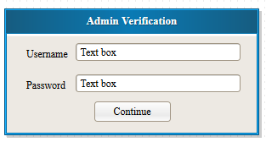

|  |  |  |  |  |
| --- | --- | --- | --- | --- |
| Input | Data Validation | Processing | Error Message | Output |
| The username is typed. | Standard username verification. |  |  |  |
| The password is entered into the password box. | Standard password verification. |  |  |  |
| Continue button clicked. | The above verification is run. | The password and username is checked to run. |  | This window is used to check whether or not this is an admin. The window will close and the admin function they selected previously is opened. |

### Add App

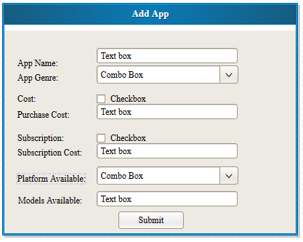

|  |  |  |  |  |
| --- | --- | --- | --- | --- |
| Input | Data Validation | Processing | Error Message | Output |
| User specifies the App name |  |  |  |  |
| The user specifies the genre of the app. |  |  |  |  |
| User specifies whether there is cost to buy the app. |  |  |  |  |
| User specifies the purchase cost of the app. | The cost is checked to be a number. |  | The cost entered was not a number. |  |
| User specifies Subscription if the |  |  |  |  |
| User specifies subscription cost of the App. | The cost is checked to be a number. |  | The cost entered was not a number. |  |
| The platform that the app is available on is specified. |  |  |  |  |
| The phone models that the app is available on. |  |  |  |  |
| Submit is clicked. | All above checks are run. | An insert query is run to insert it into the database. |  | A message tells them the app was added to the database. They are returned to the main menu. |

### Edit App

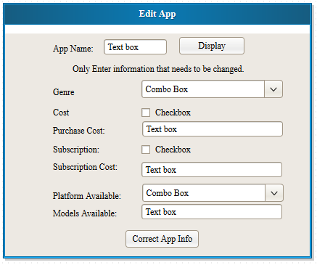

|  |  |  |  |  |
| --- | --- | --- | --- | --- |
| Input | Data Validation | Processing | Error Message | Output |
| The Name of the App they wish to alter the information for. |  |  | A message explains if the app does not exist and asks them to check the spelling again. |  |
| The Display button is clicked. |  | The app is found in the database. |  | All the information regarding the app, from the query, is put into the text boxes, etc. below. |
| The user selects what they wish to change and fills in the relevant information. | The costs are checked to only be numbers. |  |  |  |
| The correct app info button is pressed. | All above checks are run. | The info of the app is updated in a query to the database. |  | A message tells them the information has been corrected and |

### Commend User

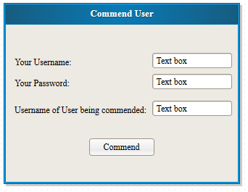

|  |  |  |  |  |
| --- | --- | --- | --- | --- |
| Input | Data Validation | Processing | Error Message | Output |
| The username is entered. | The username is checked to have the right length and contents. |  |  |  |
| The password is typed in. | The password is checked to have the right length and contents. |  |  |  |
| The username of the user the administrator wishes to commend. |  |  |  |  |
| The commend button is clicked. |  | The update query is run, increasing the amount of commendations by one. |  | The user is informed that everything worked and the main menu is opened. |

### Ban User

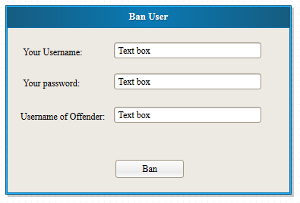

|  |  |  |  |  |
| --- | --- | --- | --- | --- |
| Input | Data Validation | Processing | Error Message | Output |
| The username of the administrator is typed in. | The username length and characters are checked. |  |  |  |
| The password is typed in. | The password length and characters are checked. |  |  |  |
| The username of the user the administrator wishes to ban. |  |  |  |  |
| The ban button is clicked. |  | A delete query is sent to the database to remove the user. |  | The user is banned, a message explains this. The screen closes and the main menu reopens. |

## Operators

At a later date we will have another GUI on the server system so we can create queries to gain marketing information.

# Database Specifications

## Table Relations

### AppTbl

# AppID

- AppName

- Cost

- PurchaseCost

- Subscription

- SubscriptionCost

### GenreTbl

**- GenreName**

**+ App**

### AdminVoteTbl

+ User

+ Admin

### CompatabilityTbl

+ App

- Platform

- ModelAvailable

### UserTbl

# UserID

- FirstName

- Surname

- AccountDevice

- Email

- IsAdmin

### ReviewTbl

# ReviewNo

+ User

+ App

- Record

1

∞∞

∞

∞

1

1

∞

∞

Legend

# Primary Key Field

+ Foreign Key Field

- Standard Field

## Table Specifications

|  |  |  |
| --- | --- | --- |
|  | CompatabilityTbl |  |
| Field Name | Field Type | Field Length |
| App | Text | N/A |
| Platform | Text | 15 |
| ModelAvailable | Text | 30 |

|  |  |  |
| --- | --- | --- |
|  | GenreTbl |  |
| Field Name | Field Type | Field Length |
| GenreName | Text | 15 |
| AppID | Number | Long Integer |

|  |  |  |
| --- | --- | --- |
| AdminVoteTbl*** | | |
| Field Name | Field Type | Field Length |
| User | Text | 10 |
| Admin | Text | 10 |

|  |  |  |
| --- | --- | --- |
|  | AppTbl |  |
| Field Name | Field Type | Field Length |
| AppID | Autonumber | N/A |
| AppName | Text | 15 |
| Cost | Boolean | N/A |
| PurchaseCost | Currency | Currency |
| Subscription | Boolean | N/A |
| SubscriptionCost | Currency | Currency |

|  |  |  |
| --- | --- | --- |
|  | Users |  |
| Field Name | Field Type | Field Length |
| UserID | Text | 10 |
| FirstName | Text | 15 |
| Surname | Text | 15 |
| AccountDevice | Text | 15 |
| Email | Text | 20 |
| IsAdmin | Boolean | N/A |

|  |  |  |
| --- | --- | --- |
|  | ReviewTbl |  |
| Field Name | Field Type | Field Length |
| ReviewNo | Autonumber | N/A |
| User | Text | 15 |
| App | Text | 15 |
| Record* | Text | 30 |

*Record is the nondependent code used to identify and call the text document containing the review.

***This table holds all the votes made by admins for users. If a user has five votes from admins, they themselves become an administrator.

# Data Structures

|  |
| --- |
| Server |
| + ArrayList<Reviews> |
| + void listen()  + ResultSet executeQuery(String statement)  + void executeUpdate(String statement) |

# Classes

PrimeWindow(Main class)

|  |
| --- |
| **AccessDB** |
| + String SERVER |
| + void connect(String SERVER)  + boolean isConnected()  + void disconnect() |

|  |
| --- |
| **DataValidation** |
|  |
| + boolean isEmail(String email)  + boolean isName(String name)  + boolean validAge(String age) |

All other GUI windows and panes

|  |
| --- |
| **ManagementSystem** |
|  |
| + boolean addApp(String appName, boolean cost, String purchaseCost, boolean subscription, String subscriptionCost)  + boolean addUser( String[] fullName , String accountDevice, String email, boolean isAdmin)  + boolean removeUser(String username)  + boolean editApp(String appName, String availablePlatforms)  + boolean editApp(String appName, String price) |

|  |
| --- |
| MailServer |
| + ArrayList<Emails> |
| + void listen()  + void populateArrayList()  + void sendLogIn()  + String makeUsername()  + String makePassword()  + ResultSet executeQuery(String statement)  + void executeUpdate(String statement) |

Continued:

|  |
| --- |
| Server |
| + ArrayList<Reviews>  + ServerSocket serverSock  + Packet packet |
| + void listen()  + ResultSet executeQuery(String statement)  + void executeUpdate(String statement) |

|  |
| --- |
| enum Packet extends java.lang.Enum |
| UPDATE,DELETE,SELECT,CREATEUSER,MAILMESSAGE, ADMINUPGRADE, |
|  |

|  |
| --- |
|  |
| Access Database |
|  |

|  |
| --- |
| UserCreation |
| + String username  + String password |
| + String createUsername()  + String createPassword() |

## Review Management

The reviews table will have an ID which is the review number; this will be used to reference text files with the number as the first line, the other lines containing the reviewer, the app reviewed as well as the review itself in a text file. This will save space in the database and allow for a complex and elegant storage of the files on the server.